**Pizza Sales SQL Queries**

1. **KPI**

-- Total Revenue

select ROUND(sum(total_price),2) as 'REVENUE'

from piza;

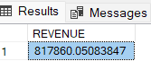

--Avg. Order Value

SELECT round(sum(total_price)/count(distinct(order_id)),2) as 'avg order value' from piza;

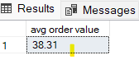

--Total Pizza Sold

select sum(quantity) 'total quantity sold' from piza;

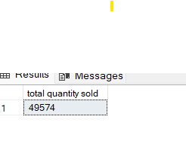

-- Total Orders Place

select count(order_id) as 'unique total order' from piza; -- one order

select count(distinct(order_id))'Total order' from piza; --more than one order

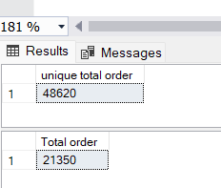

-- Avg pizza order

SELECT

CAST(CAST(SUM(quantity) AS DECIMAL(10, 2)) /

CAST(COUNT(DISTINCT order_id) AS DECIMAL(10, 2)) AS DECIMAL(10, 2)) AS 'Avg Pizza Order'

FROM

piza;

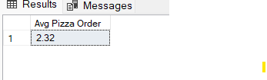

--Daily Trends

select datename(DW,order_date) as 'order day',

count(order_id) as 'total order' from piza

group by datename(DW,order_date)

order by count(order_id) desc ;

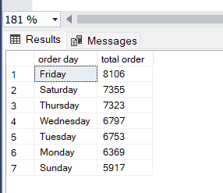

-- Monthly order

select datename(month, order_date) as 'Month_Name',count(distinct(order_id)) as 'total order'

from piza

group by datename(month, order_date)

order by count(distinct(order_id)) desc ;

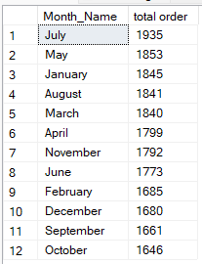

-- % Sales by Category

select pizza_category,

round(sum(total_price)*100/(select sum(total_price) from piza),2) as 'PCT'

from piza

group by pizza_category;

select * from piza;

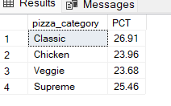

--percentage of sale by pizza size

select pizza_size,

round(sum(total_price)*100/(select sum(total_price) from piza),2) as 'PCT'

from piza

group by pizza_size;

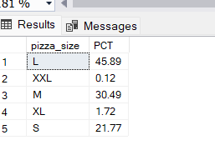

-- Top 5 Salers by revenue,Total Quantity and total orders;

select top 5 pizza_name,sum(total_price)as 'total_revenue' from piza

group by pizza_name

order by total_revenue desc;

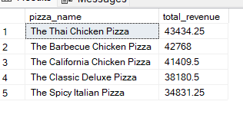

-- Top 5 Salers by revenue,Total Quantity and total orders;

select top 5 pizza_name,sum(total_price)as 'total_revenue' from piza

group by pizza_name

order by total_revenue asc;

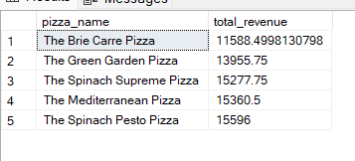

-- Top 5 Pizza by Quantity,Total Quantity and total orders;

select top 5 pizza_name,count(distinct (order_id)) as 'Top Piza' from piza

group by pizza_name

order by count(distinct (order_id)) desc;

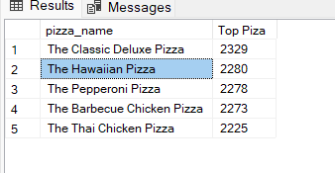

-- Botom 5 Pizza by Quantity,Total Quantity and total orders;

select top 5 pizza_name,count(distinct (order_id)) as 'Top Piza' from piza

group by pizza_name

order by count(distinct (order_id)) asc;

